Computer Programming Using Python - Console 9 page 1of2 - File I/O (input & output) & escape sequences: file write
File, New Window, File, Save As console9.py
Sometimes when are setting the value of a string, there are characters that you can’t type.
For these situations, there is something called an escape sequence:
To create a character that you can’t type literally, you use a backslash followed by a letter that stands for the special character
Example:
If you want a “new line” in a string:
mytwolines=”line1\nline2”
since “\n” is the escape sequence
for a “new line” character
Since backslash is the escape character, you also need escape sequence to use it itself:
“\\” is the escape sequence for ‘\’
This is important when writing files.
If you say:
myfile=”H:\new folder\myfile.txt”
You will get this:
H:
ew folder\myfile.txt
(that won’t work! It will be two lines!)
Why? Because \n is an escape sequence
so, to use the path ‘H:\new folder’
instead you need to type:
myfolder=”H:\\new folder”
To find a complete list
of escape sequences,
you can use docs.python.org
or google:
python escape sequences
- Open IDLE, File, New Window, File, Save As, console9fileout.py
- Type the following
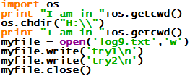
- Run, Run Module, then look for a file called “log9.txt” in your home drive (Start, Computer, your home drive, then double-click log9.txt). If the program worked the file will open in notepad and say:
try1
try2

(continued on next page)

Computer Programming Using Python - Console 9 page 2of2 - File I/O (input & output) & escape sequences: file modes

GOALS: Learn the difference between ‘w’ for write mode and ‘a’ for append mode; use append mode to make a file longer each time the program runs.

- Make sure you have finished Console 9 page 1
- Open IDLE, and open console9fileout.py
- Change it (you can delete old code) & do the following instead:
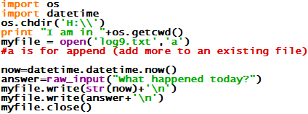

- Run, Run Module. The program will exit, but it worked if the log file is in directory you changed to, and contains
two more lines each time you run it. Each time, it should add:

(date you ran the program)
(whatever you answered)

To the log file – to check it, run the program a few times, then go to Start, Computer, your H: drive, then double-click log9.txt and make sure it contains several dates and things you typed while the program was running.

Now make a new program that can read the log your other program created and show it in the console:
- Open IDLE, File, New Window, File, Save As, console9filein.py
- Type the following code:
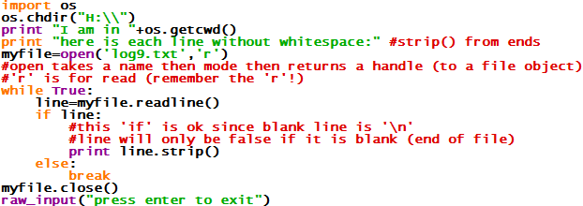

- Run, Run Module. If it works, it should show what the other program wrote (the dates and what you typed)!

